

JIMMA INSTITUTE OF TECHNOLOGY DEPARTMENT OF SOFTWARE ENGINEERING
FACULTY OF COMPUTING AND INFORMATICS
Elective I- WEB Service Assignment-2

GROUP MEMBERS ID
- Jida Guta ……………………………………………………………………………RU1644/14
- Gemeda Tamiru …………………………………………………………………….RU0227/14
- Sintayehu Bikila ……………………………………………………………………RU0207/14
- Sena Kebede ………………………………………………………………………..RU0191/14
- Meron Mulu………………………………………………………………………...RU0477/14
- Bekalu Endirias…………………………………………………………………….RU2501/13

Submitted to: Mr Dessalew Y.
November, 2025
Table of Contents
1. Introduction 3
2. Implementation Steps 3
3. Tools and Technologies Used 5
4. Results and Observations 6
5. Conclusion 6

Introduction
The objective of this assignment was to develop a mobile weather application using Flutter that integrates external web services to fetch real-time weather data. The system uses the OpenWeather API, a publicly available RESTful service, to retrieve weather information based on the city name provided by the user. The main purpose of the project is to demonstrate how Flutter applications interact with online APIs, process JSON responses, and display the results on the user interface.
The app includes a search bar where the user types a city name, and the system provides auto-suggestions to help the user quickly find valid locations. Once a city is selected, the application fetches weather details such as:
- City Name
- Country Name
- Temperature (°C)
- Humidity
- Wind Speed
This project showcases the practical use of API consumption, asynchronous programming, state management, and UI presentation in Flutter.

Implementation Steps

Step 1 — Project Setup
A new Flutter project was created using the command:
flutter create weather_app
Project dependencies such as http, and flutter_typeahead for search suggestions were added in the pubspec.yaml

Step 2 — Configuring API Integration

The OpenWeather API base URL and API key were stored securely inside a separate configuration file. A service class (weather_service.dart) was implemented to:
- Handle HTTP requests
- Send GET requests to fetch weather data
- Parse JSON responses into Dart models
- Convert temperature from Kelvin to Celsius

Step 3 — Implementing Search Functionality
A search bar was developed using a TypeAhead widget. When the user types text:
- The system sends requests to OpenWeather’s Geocoding API
- It returns recommended city names along with country codes
- The user selects one of the suggestions

Step 4 — Designing Weather UI
The UI was implemented using:
- A clean layout with city and country name
- A large temperature display
- Icons for humidity and wind speed
The weather data is displayed using Flutter widgets like:
- Column
- Row
- Container
- Text
- Icon

Step 5 — Testing the API Connection
The following tests were performed:
- Valid city search returns correct data
- Invalid city name shows error message
- API response time is smooth
- Internet connection failure triggers proper error handling

Tools and Technologies Used

Software & Frameworks
- Flutter SDK (Dart language)
- VS Code (IDE for development)
- OpenWeather API (REST API for weather data)
- HTTP package (for API communication)
- flutter_typeahead (city name suggestions)
- JSON Formatter (to analyze API responses)

Testing Tools
- Postman (testing API endpoints)
- Physical Device

Version Control
- Git & GitHub (for code management)

Results and Observations
During development, the API was successfully integrated, and the application was able to retrieve and display all required weather details. Below are the expected results:

Successful API Response
A sample JSON response received from OpenWeather:
{
"name": "London",
"sys": { "country": "GB" },
"main": { "temp": 289.5, "humidity": 65 },
"wind": { "speed": 3.6 }
}
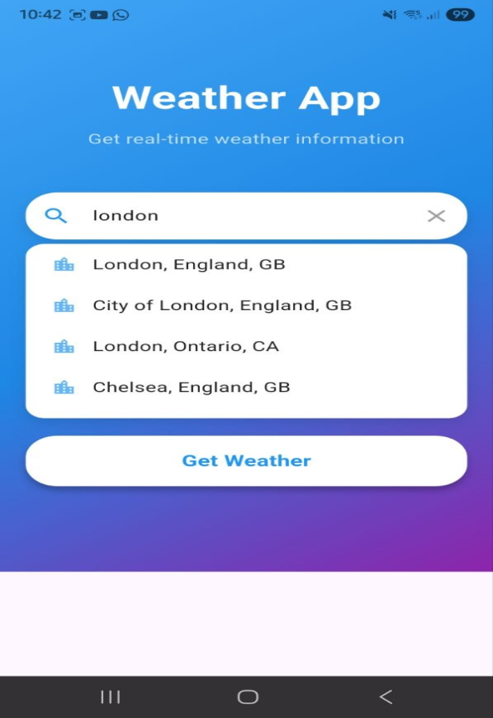
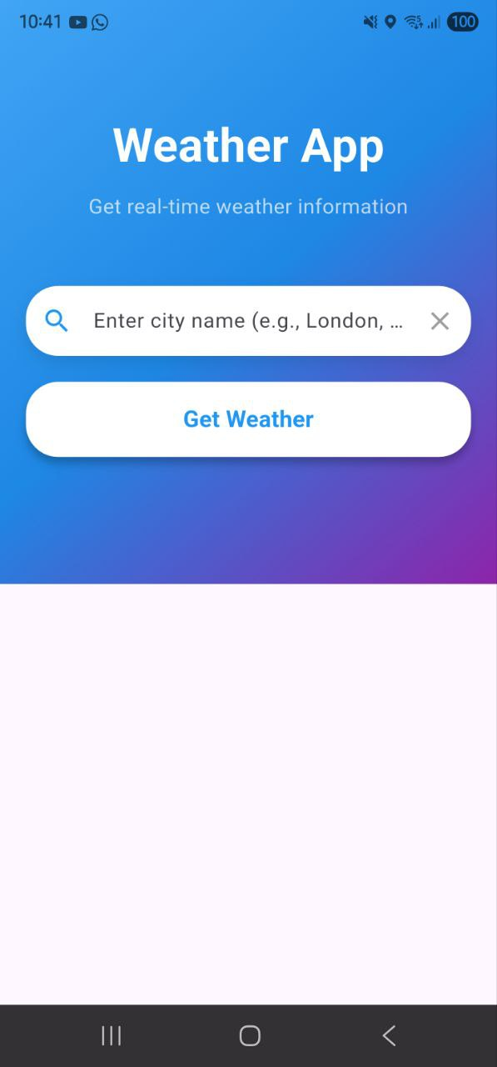

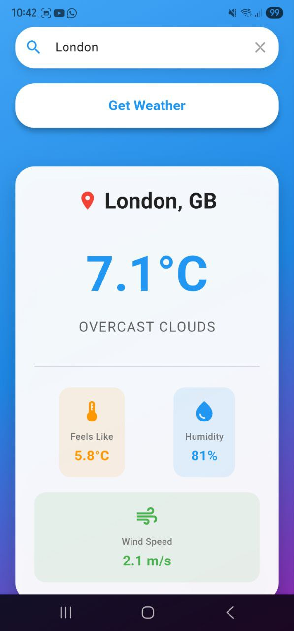
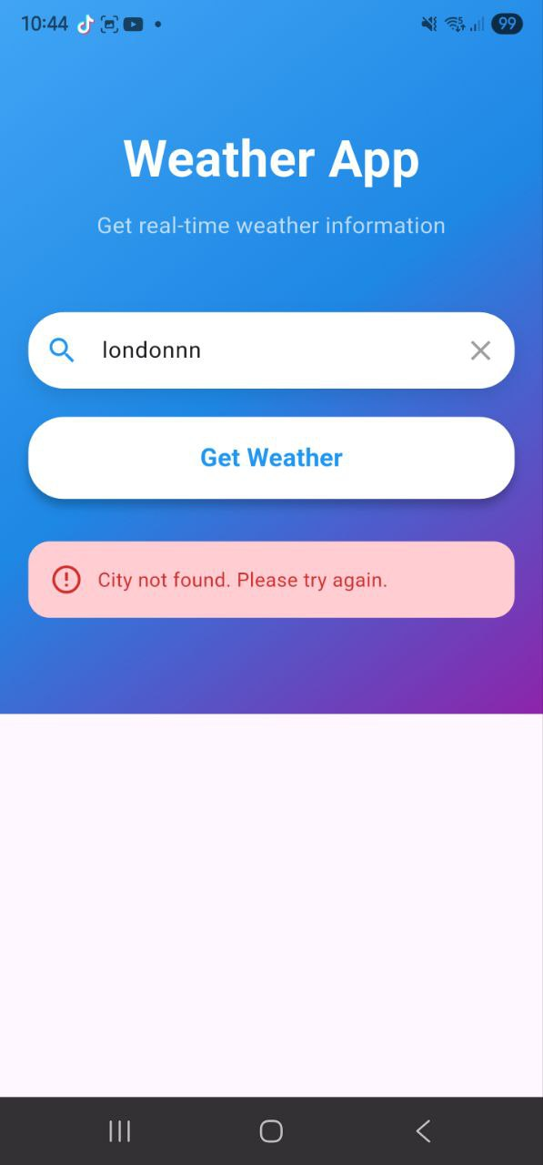

Conclusion
The development of the Flutter weather application provided a comprehensive understanding of how mobile apps interact with external web services. By integrating the OpenWeather API, the application was able to fetch accurate and real-time weather data, demonstrating the effectiveness of REST APIs in modern mobile development.
Throughout this project, several important concepts were learned:
- API Integration Workflow: How to send GET requests, attach API keys, handle responses, and parse JSON data.
- State Management: Managing UI updates efficiently when new weather data is received.
- Search Optimization: Implementing auto-suggestions using the Geocoding API improved usability and reduced user errors.
- Error Handling: Ensuring the app responds gracefully to invalid input, no internet connection, or failed API responses.
- Security Awareness: Understanding the importance of protecting API keys, avoiding hardcoding, and using secure configuration files.
- Performance Considerations: Observing API response time, caching techniques, and optimizing the UI for smooth performance.
- User Interface Design: Presenting fetched weather data in a clean, intuitive, and user-friendly layout.
In summary, this assignment strengthened practical skills in Flutter development, improved understanding of RESTful APIs, and demonstrated real-world integration techniques that are essential in professional mobile application development. The experience gained will be valuable for building more advanced applications that rely on external services, authentication, and secure data exchange.

